Feelings/Group Hametner

Dealing with feelings | Collect all the feelings you know on a sheet of paper. Mime one of the words for the others to guess.  How do these people feel?  Creative gap writing text  Put in the feeling word that fits best into the sentence. Use your imagination! | handout  handout
Music and emotions | Listen to some songs (by Riccardo Cocciante, Enya, Bob Marley, Metallica)  and describe your feelings. | Cd-player
Gallery of feelings  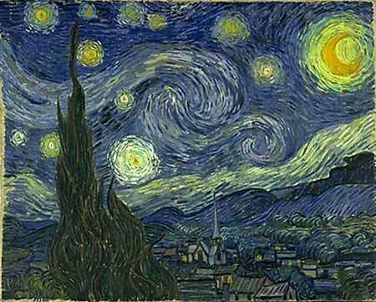 | Look at the following pictures; which feelings do they evoke in you? Discuss in groups.  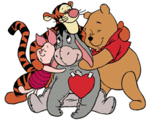 | pictures

Stories and feelings – the language of feelings  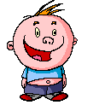  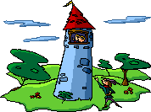 | Guess the mime story  Work in groups of four; invent a story which you can mime so clearly that other goups will know what the story is about. The mime should show feelings such as happiness, anger, and must not last longer than three minutes. The other groups guess what your story is all about.  A fairy tale with holes in it  Put the words from the word list into the holes. Enjoy the funny or even crazy outcome of your fairy tales. | handout
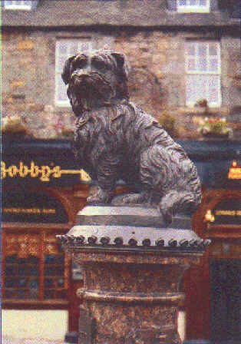  The Tale of Greyfriars Bobby | Read the story and describe your feelings for the dog and his behaviour/character/fate.  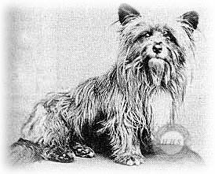 | reading corner  book

Mary Poppins  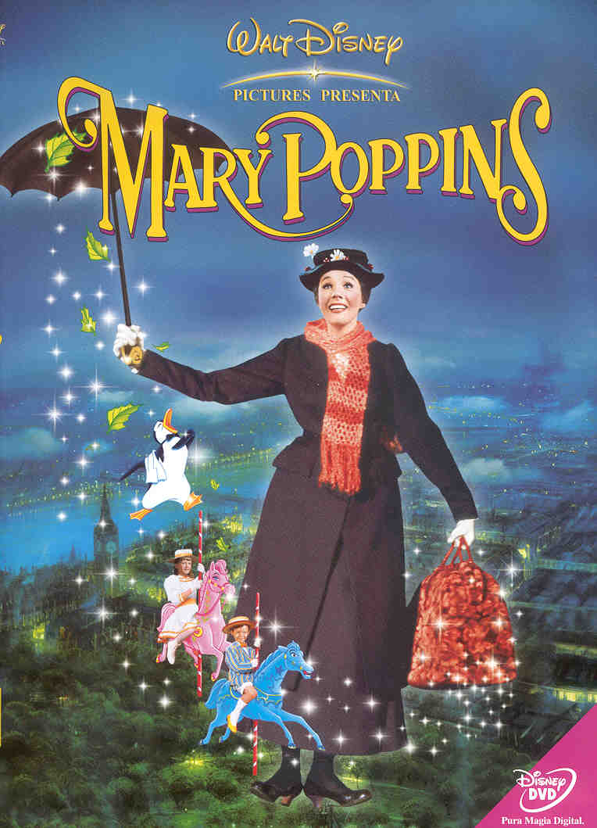 | Watch the scene from the film Mary Poppins; how do the children feel about their nanny? Would you also like to have a companion/ friend with magic abilities. Have a conversation with your teacher. | TV-set
A bad day | Match the pictures with the sentences.  Write out the picture story. | handout

